Art as Evidence
The years between World War I and World War II were tumultuous. In this exercise you will examine several pieces of art and then complete this worksheet responding to the following statement:

In the 20 years between World War I and World War II economic and social conditions for most Americans improved dramatically.

This assignment is worth 20 points.

Thesis:__________________________________________________________________________________________________________________________________________________________________________________________________________________________________________________________________________________________________________________________________________________________________________________________________________________________________________________________________________________________________________________________________________________________________________________________________________________________________________________________________________________________________

Evidence #1
Art Piece #

How does it help your argument (be specific—using content from the source)

___________________________________________________________________________________________________________________________________________________________________________________________________________________________________________________________________________________________________________________________________________________________________________________________________________________________________________________________________________________________________________________________________________________________________________________________________________________

Evidence #2
Art Piece #

How does it help your argument (be specific—using content from the source)

___________________________________________________________________________________________________________________________________________________________________________________________________________________________________________________________________________________________________________________________________________________________________________________________________________________________________________________________________________________________________________________________________________________________________________________________________________________

Evidence #3
Art Piece #

How does it help your argument (be specific—using content from the source)

___________________________________________________________________________________________________________________________________________________________________________________________________________________________________________________________________________________________________________________________________________________________________________________________________________________________________________________________________________________________________________________________________________________________________________________________________________________

Evidence #4
Art Piece #

How does it help your argument (be specific—using content from the source)

___________________________________________________________________________________________________________________________________________________________________________________________________________________________________________________________________________________________________________________________________________________________________________________________________________________________________________________________________________________________________________________________________________________________________________________________________________________

Evidence #5
Art Piece #

How does it help your argument (be specific—using content from the source)

___________________________________________________________________________________________________________________________________________________________________________________________________________________________________________________________________________________________________________________________________________________________________________________________________________________________________________________________________________________________________________________________________________________________________________________________________________________

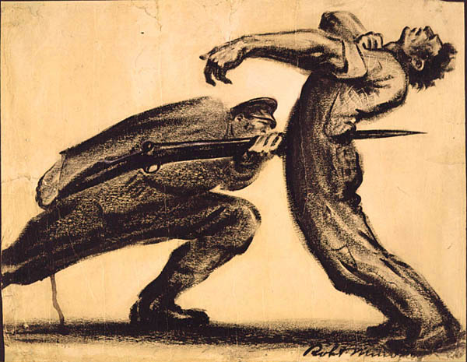
Robert Minor. Pittsburgh (1916)

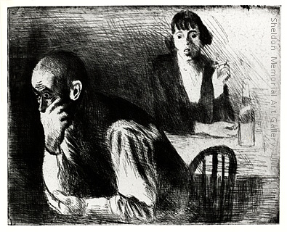
Raphael Soyer (1899-1987), Furnished Room 1937

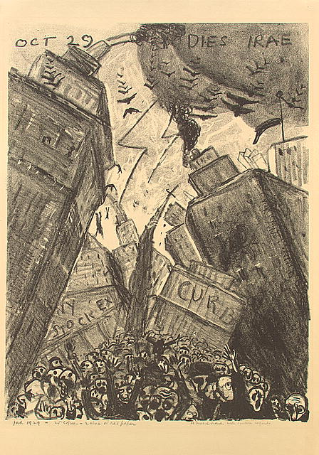
James N. Rosenberg, Oct 29 Dies Irae ("Days of Wrath"), 1929

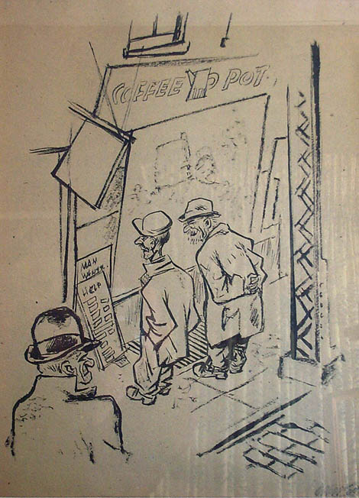
William Gropper, The Coffee Pot (1932)

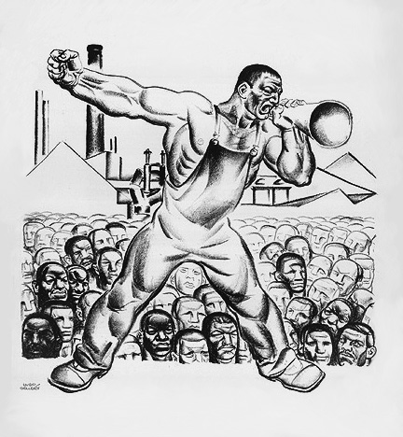
Hugo Gellert, Primary Accumlation 19 (1933)
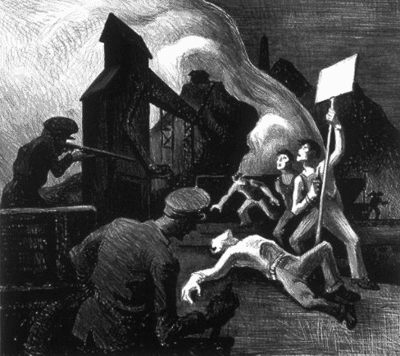
Thomas Hart Benton, Mine Strike 1933
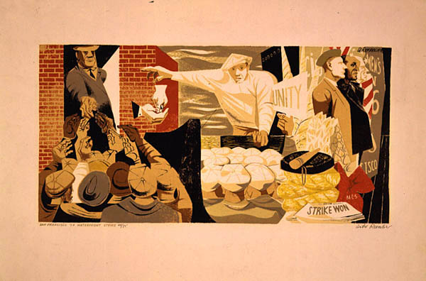Anton Refregier, San Francisco '34 Waterfront Strike (1940-48)

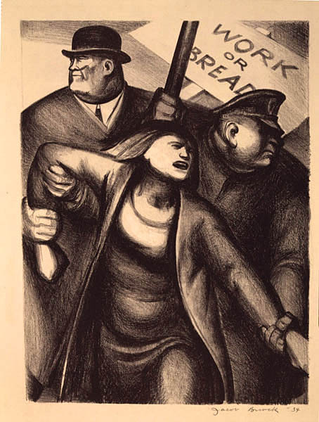
Jacob Burck, The Lord Provides (1934)

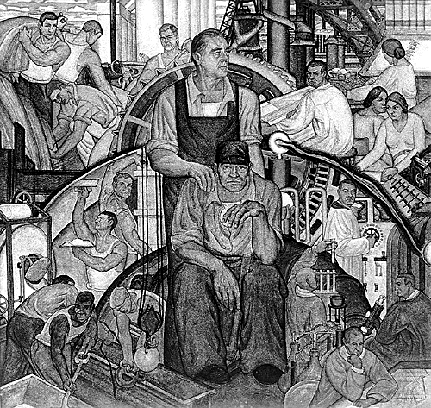
Conrad A. Albrizio, The New Deal (1934)

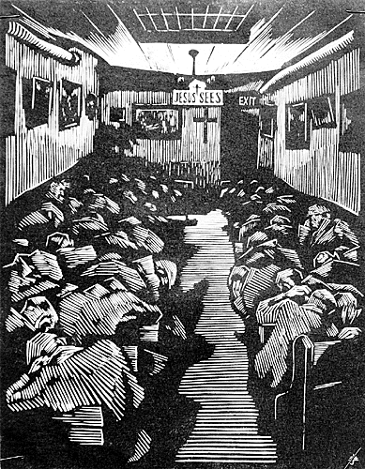
Eli Jacobi, All Night Mission (n.d.)

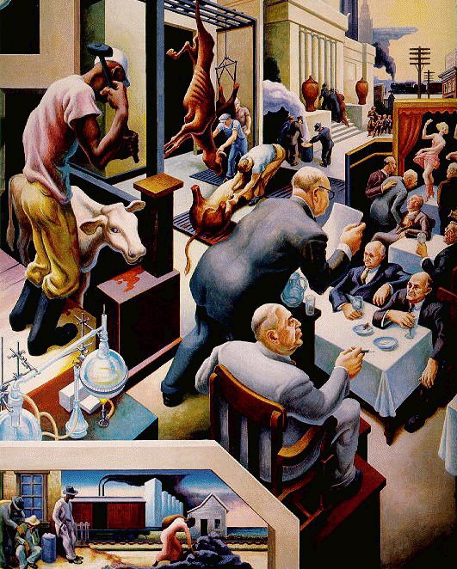
Thomas Hart Benton, "Kansas City," from Politics, Farming, and the Law,
Missouri State Museum (1936)

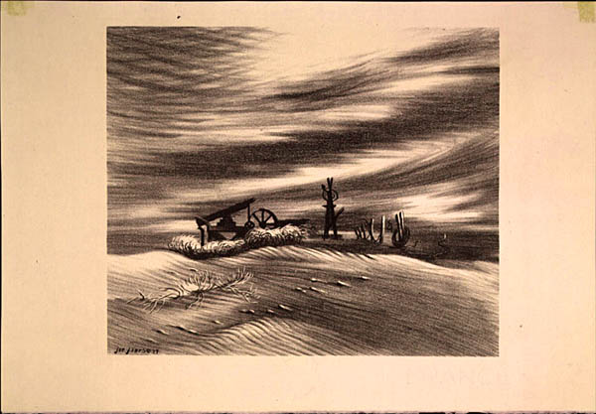
Joe Jones, Wasteland (1937)

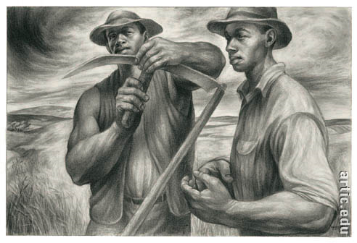
Charles White, Harvest Talk 1954

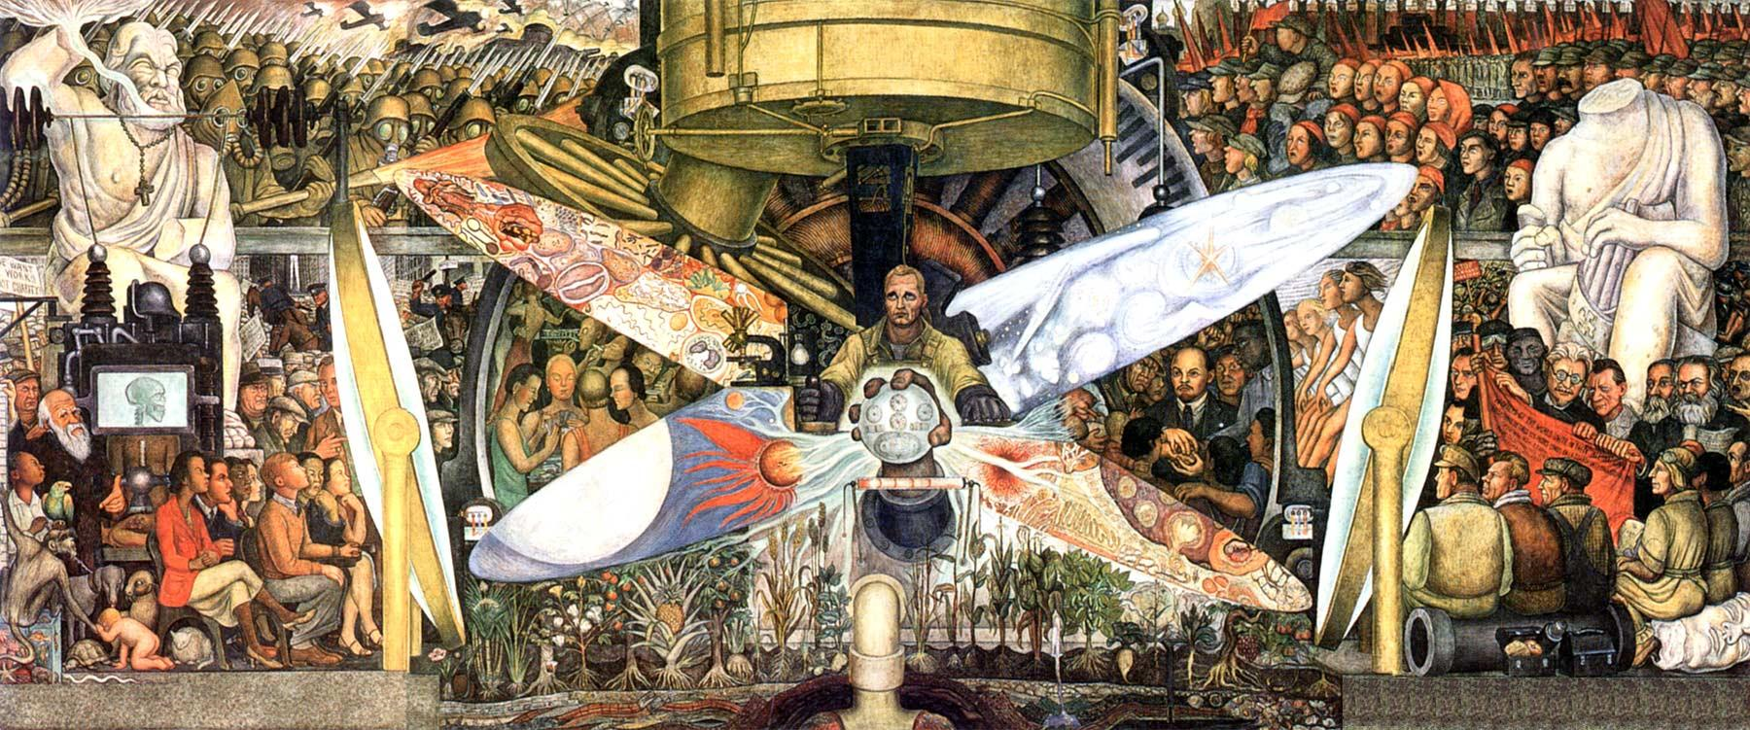
Diego River, Man at the Crossroads 1934

